30.19: a) 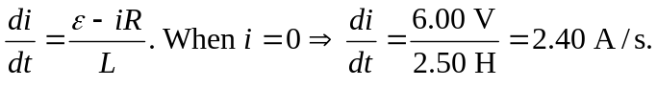
b) When 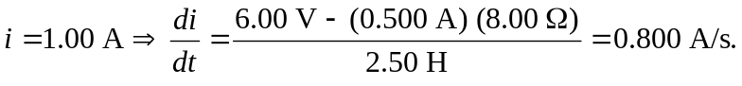
c) At
d) As 